EXPNO 11: CREATE A CLONING OF A VM AND TEST IT BY LOADING THE PREVIOUS VERSION/CLONED VM.

AIM: To create a cloning of a VM and test it by loading the previous version/cloned VM.

PROCEDURE:
STEP 1: GO TO VM AND GOTO MANAGE AND CLICK CLONE
STEP 2: CLICK CLONE
STEP 3: SELECT THE FULL CLONE
STEP 4: AFTER CLONE AGAIN OR VM IS OPENED.

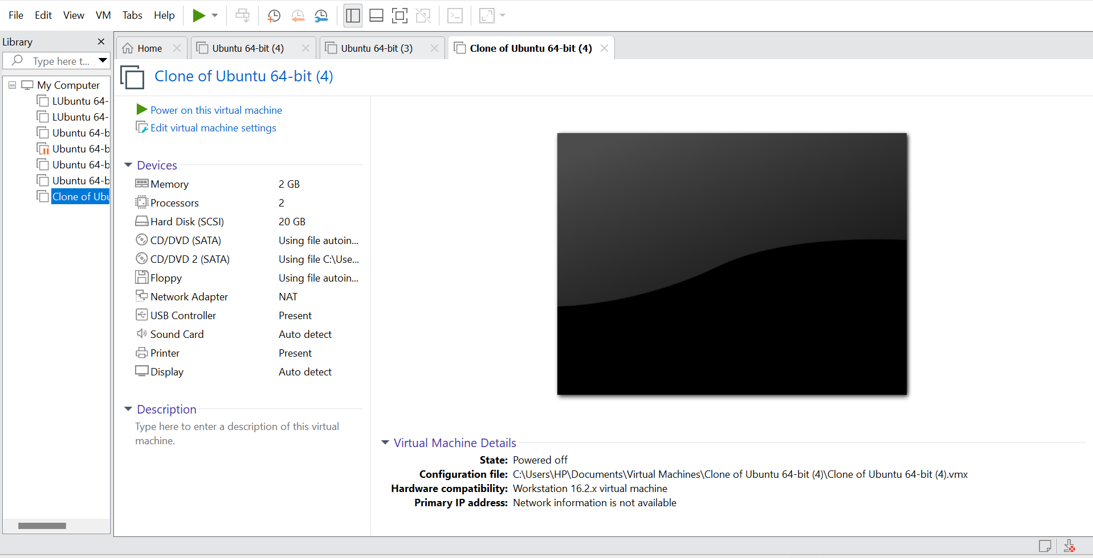
IMPLEMENTATION:

RESULT:
Thus cloning of a VM and test it by loading the previous version/cloned VM was done successfully.

